**2.Create a simple cloud software application for Flight Reservation System**

**using any Cloud Service Provider to demonstrate SaaS.**

**Aim**

To design and implement a cloud-based Flight Reservation System in Zoho Creator with forms for Passenger Details and Reservation Details, and provide it as a Software as a Service (SaaS) application.

**Procedure**

1. **Create Application**
   * Log in to Zoho Creator.
   * Create a new application named Flight Reservation System.
2. **Design Passenger Details Form**
   * Add fields:
     + Passenger Name (Single Line)
     + Age (Number)
     + Gender (Dropdown: Male, Female, Other)
     + Contact Number (Phone)
     + Email (Email field)
     + Passport Number (Single Line – optional)
3. **Design Reservation Details Form**
   * Add fields:
     + Passenger (Lookup from Passenger Details form)
     + Flight Number (Dropdown / Lookup if Flight Details form exists)
     + Date of Journey (Date-Time)
     + Number of Seats (Number)
     + Reservation Status (Dropdown: Confirmed, Pending, Cancelled)
     + Booking Reference ID (Auto Number)
4. **Configure Workflows (Optional)**
   * Add a workflow in Reservation Details form to check seat availability.
   * Automatically mark reservations as Confirmed or Pending.
   * Send confirmation email to the passenger.
5. **Deploy as SaaS**
   * Save and share the app.
   * Zoho Creator hosts the application online, making it accessible through a browser or mobile device.

OUTPUT:

PASSENGER DETAILS:

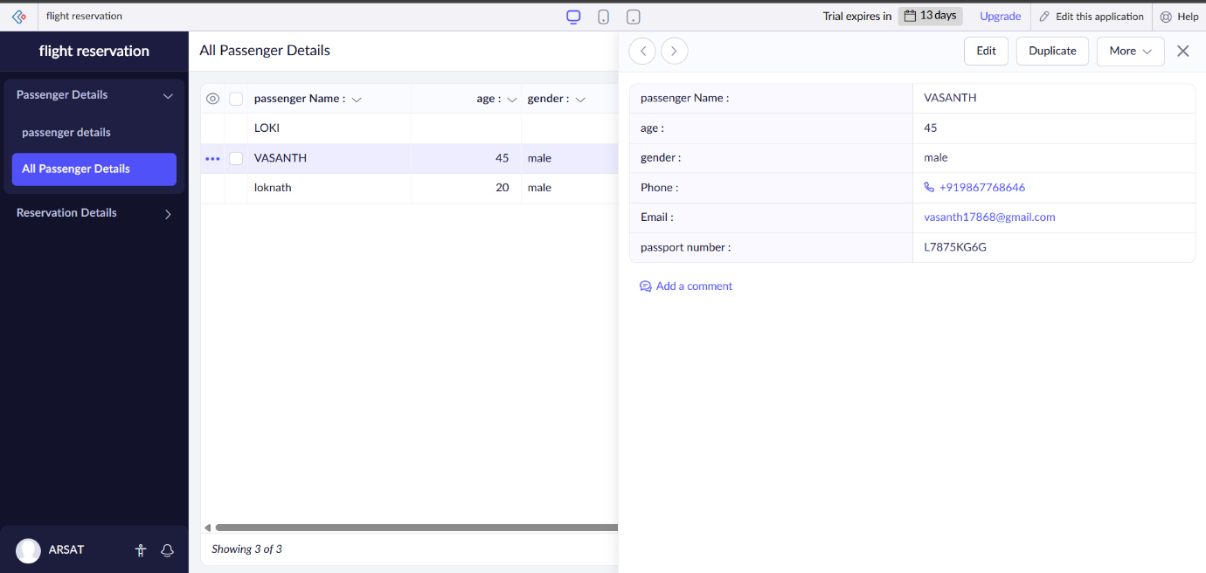

RESERVATION DETAILS:

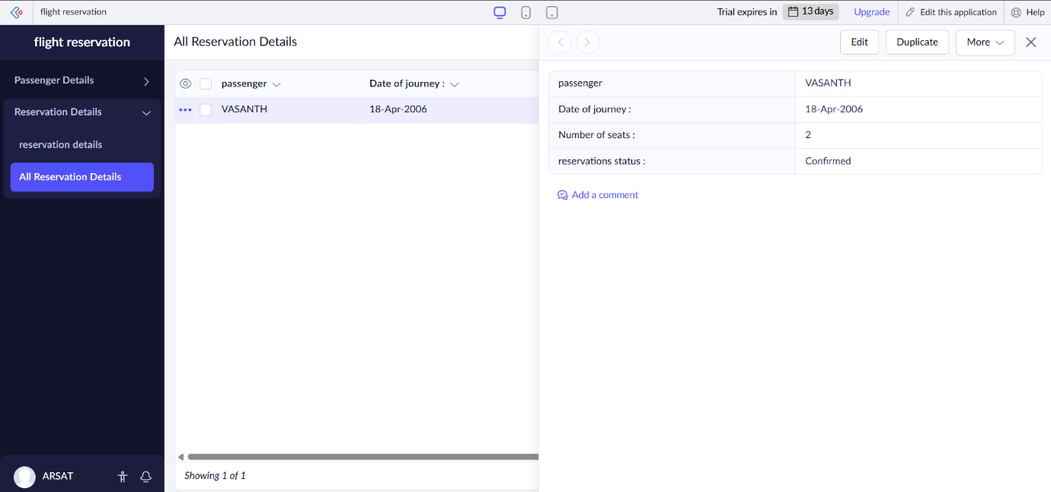

**Result**

A cloud-based Flight Reservation System was successfully created in Zoho Creator with modules for managing Passenger Details and Reservation Details.